Question 1:

Fruits Question.

Building KNN classifier model from the scratch.

Cell 1: Importing the dataset

Cell 2: Snippet of the dataset.

Cell 3: Scatter plot of mass and width

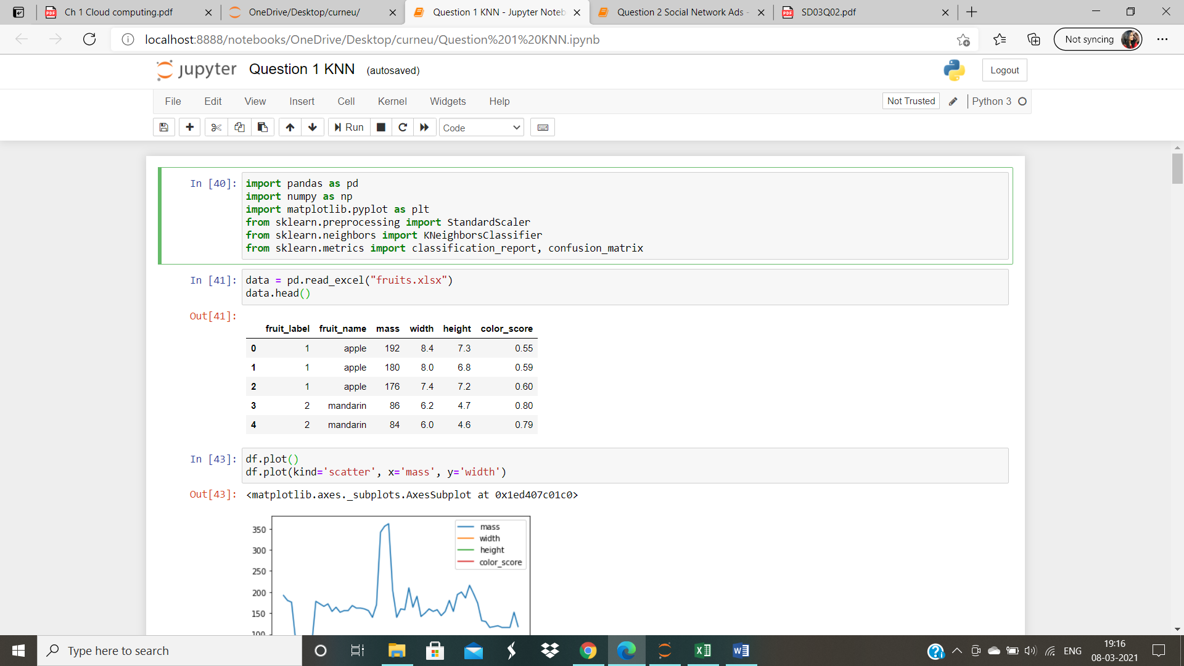

Cell 4: Scatter plot of mass and height

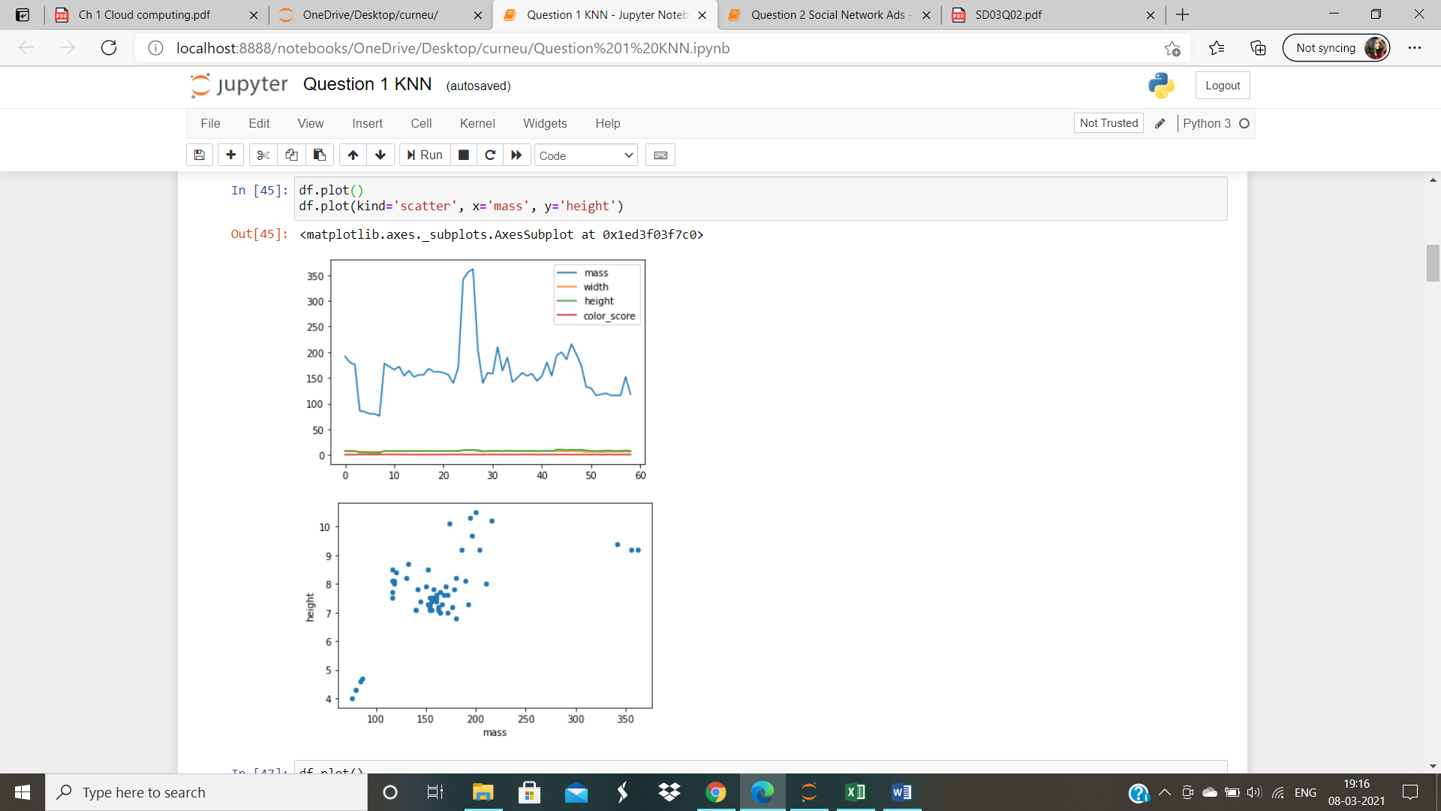

Cell 5: Scatter plot of height and width

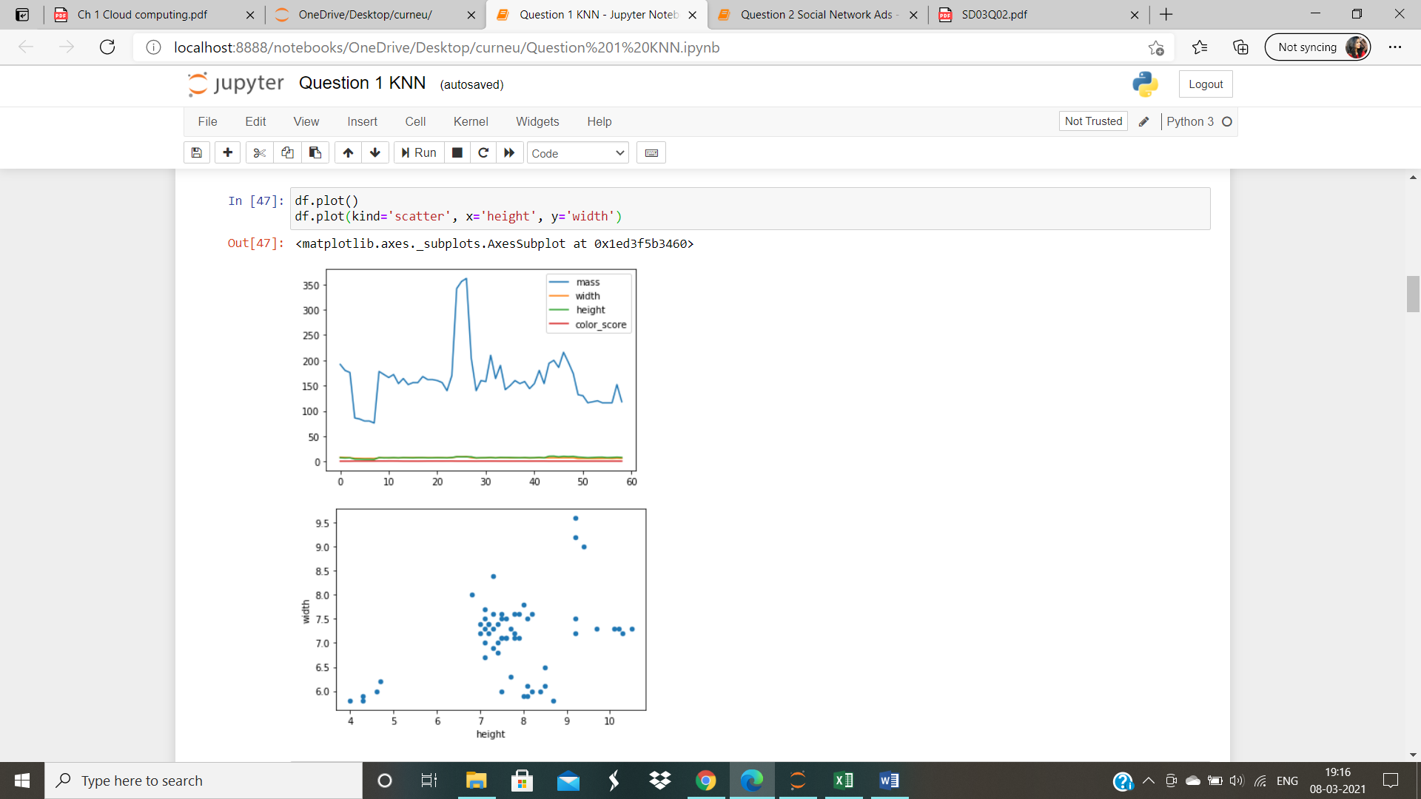

Cell 6: Scatter plot of mass and color_score

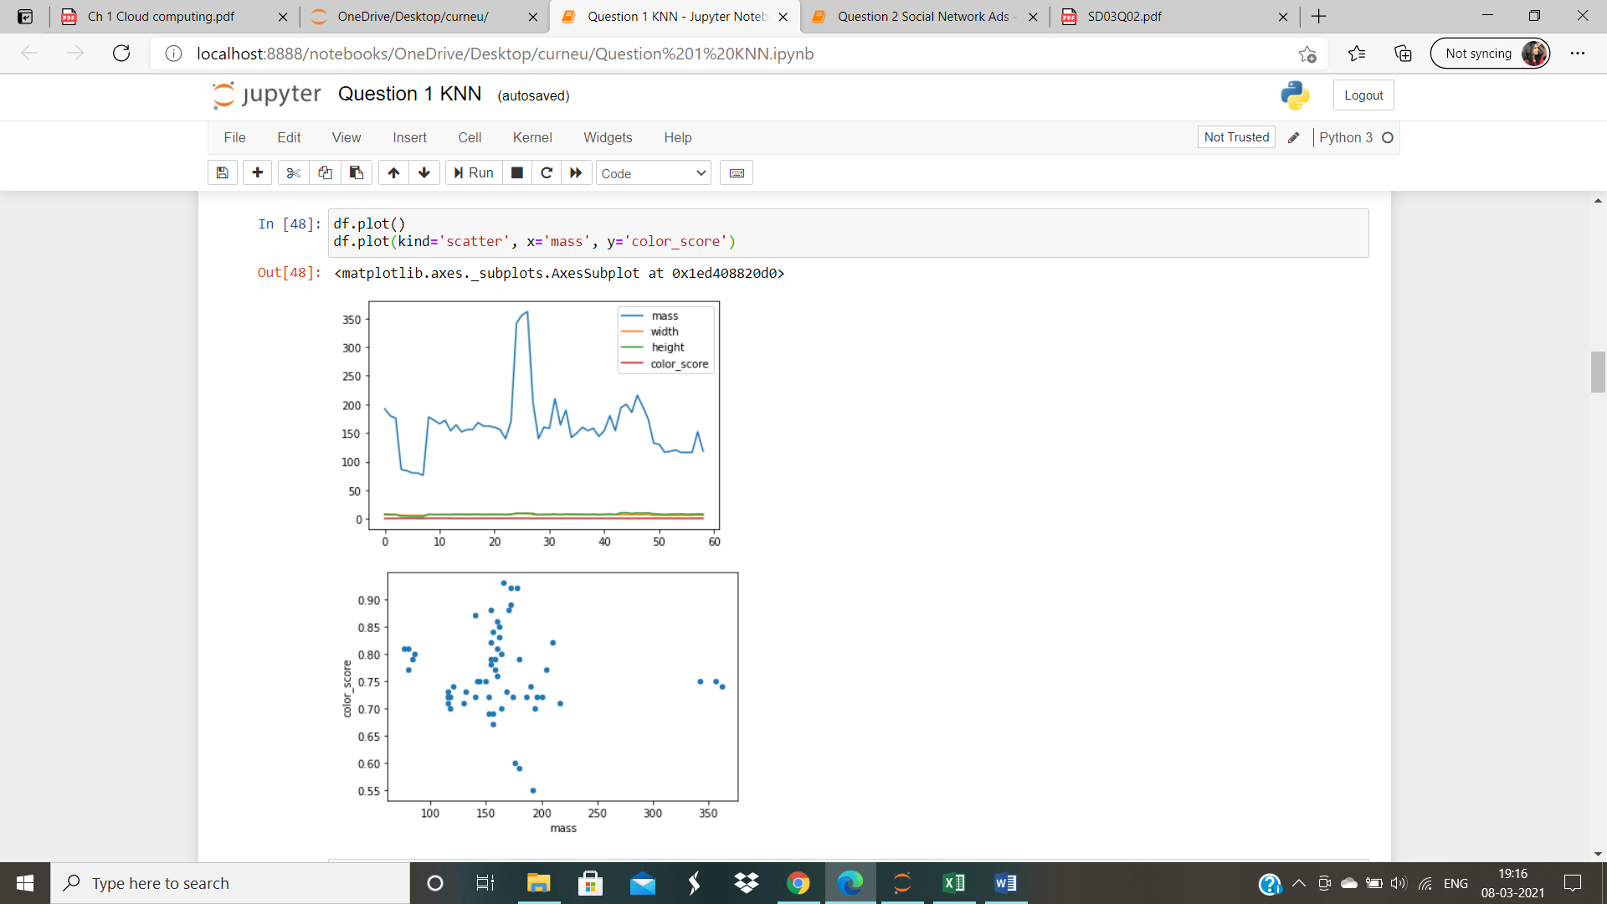

Cell 7: Scatter plot of height and color_score

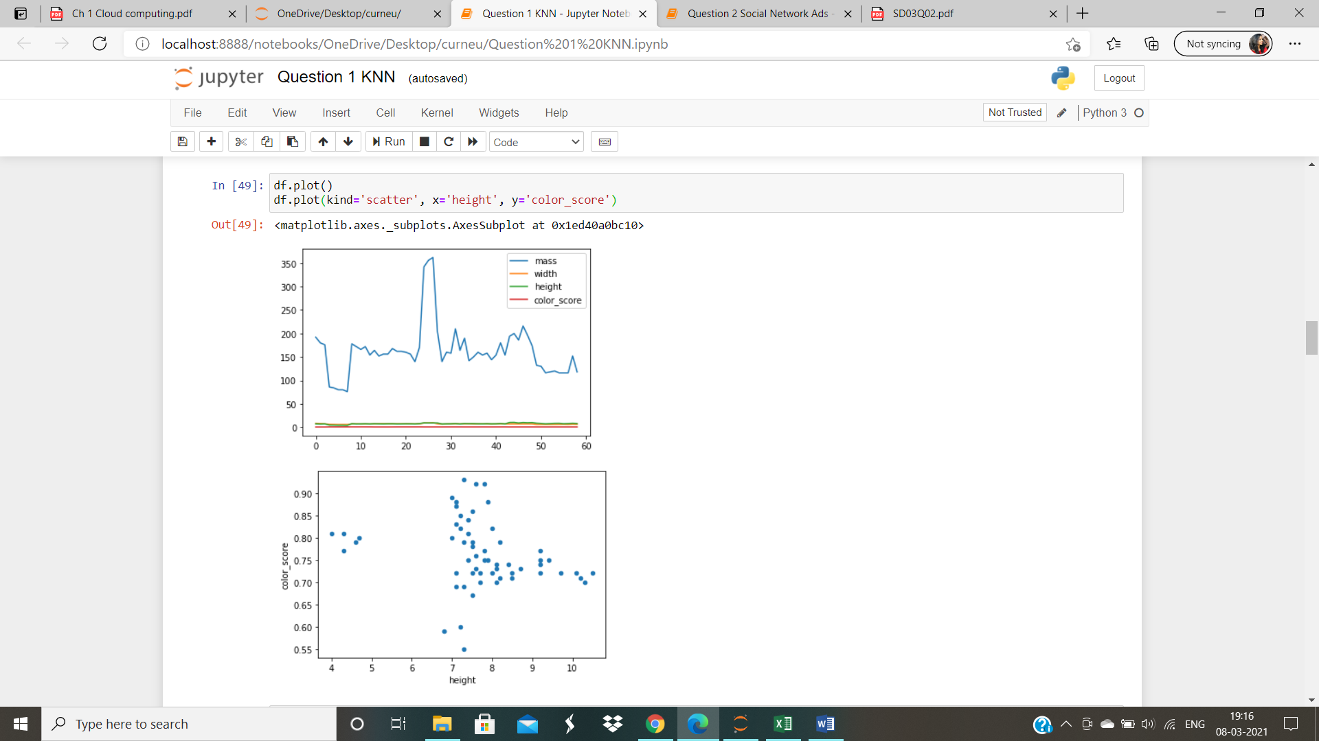

Cell 8: Scatter plot of height and width

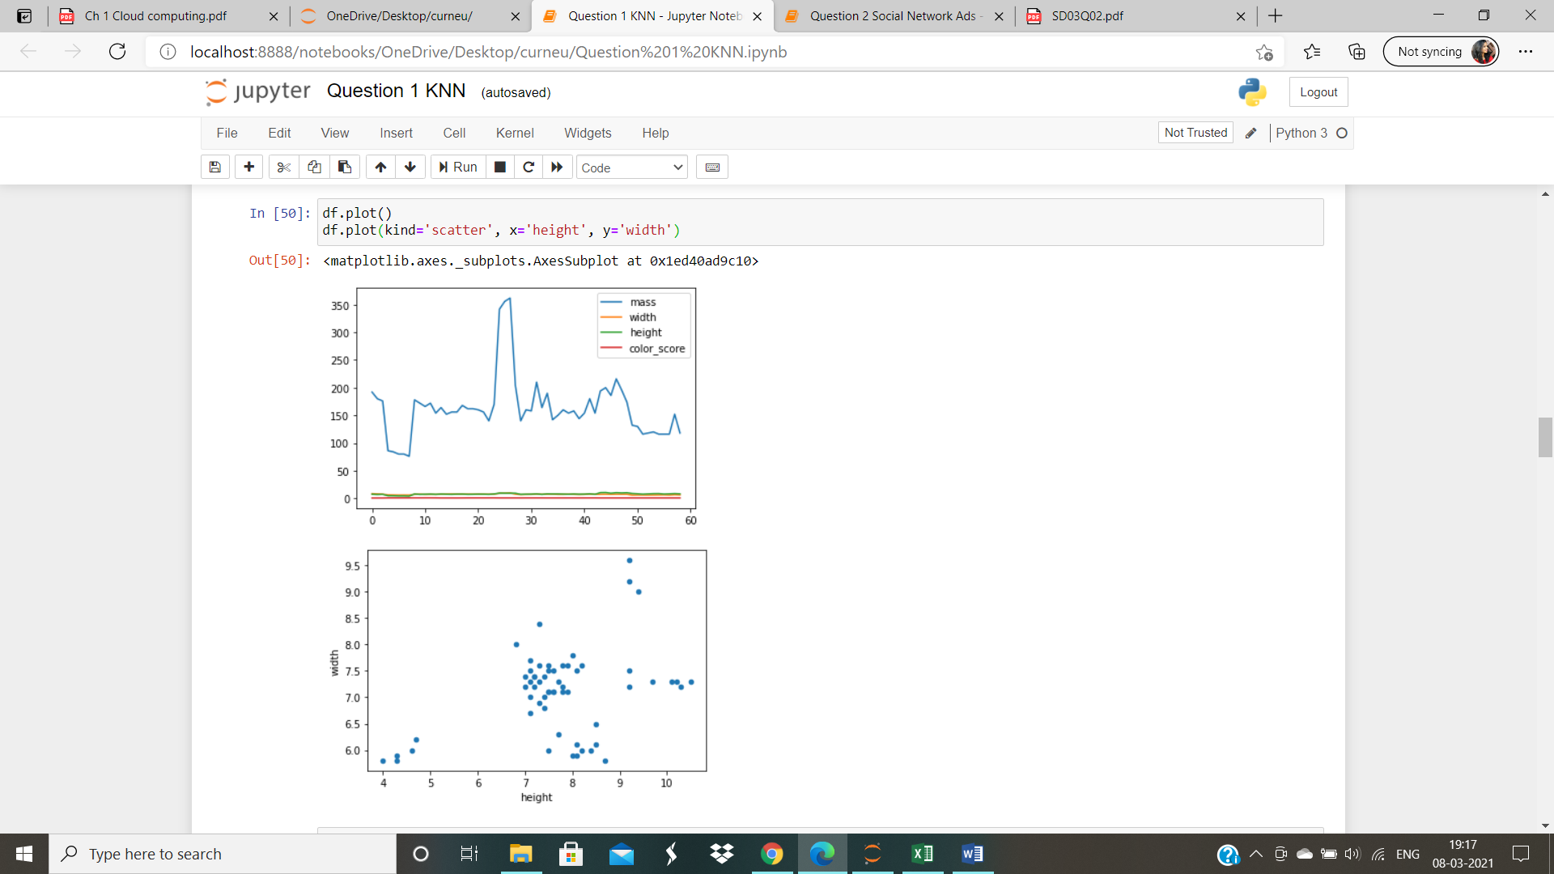

Cell 9: Scatter plot of height and mass

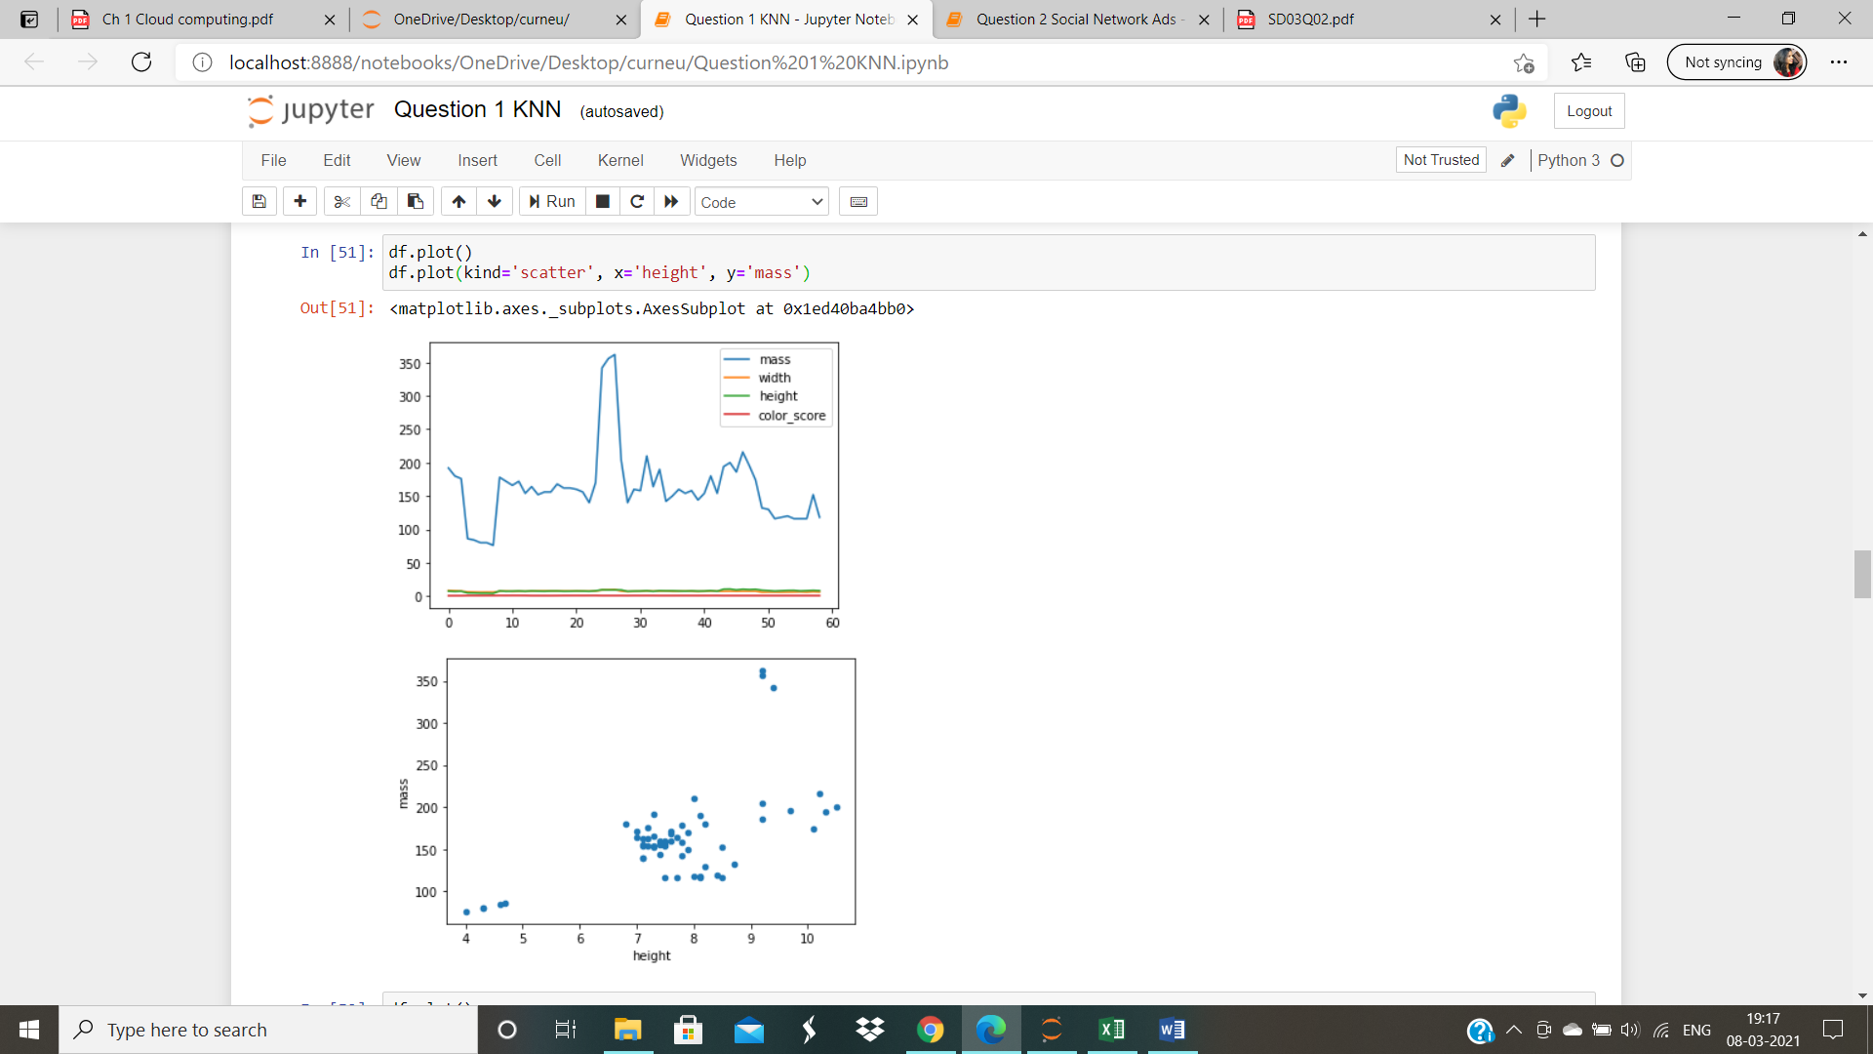

Cell 10 : Scatter plot of width and mass

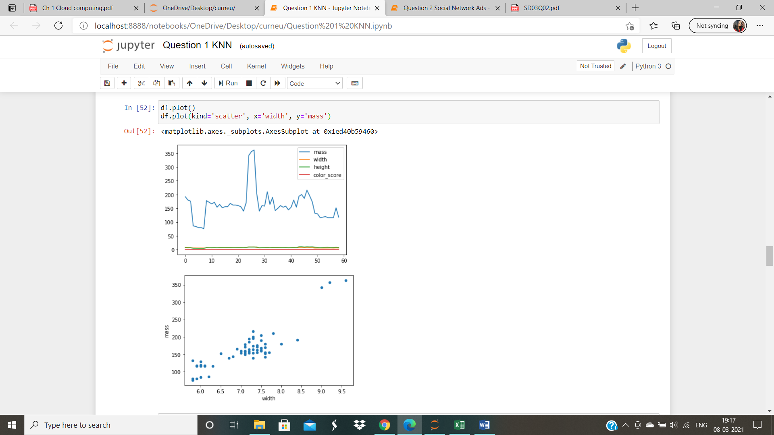

Cell 11: Scatter plot of width and height

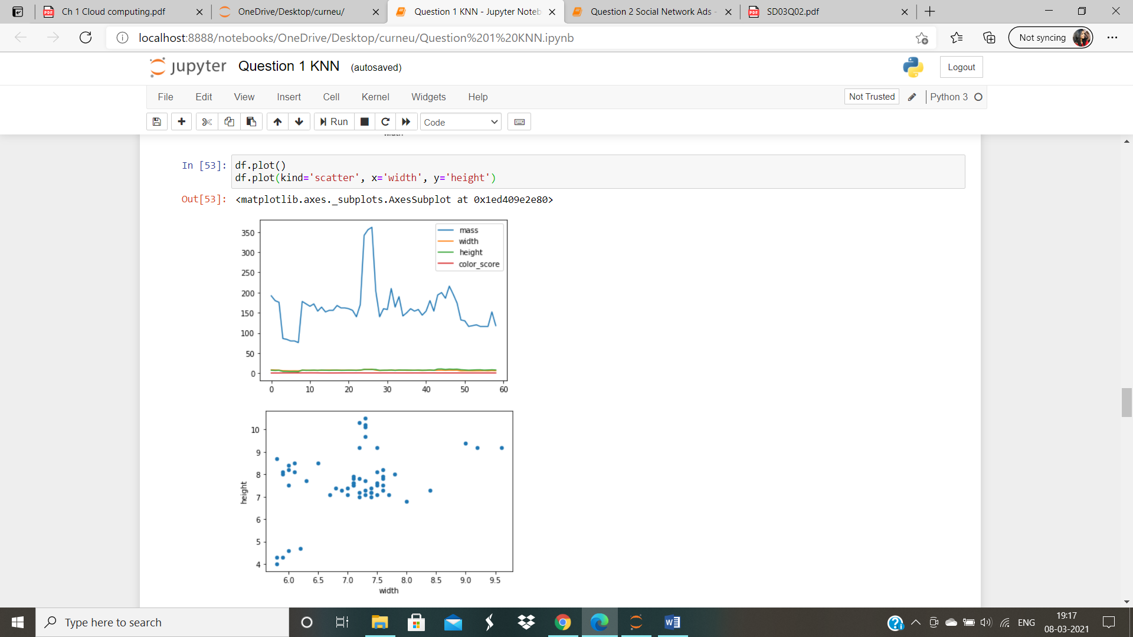

Cell 12: Scatter plot of width and color_score

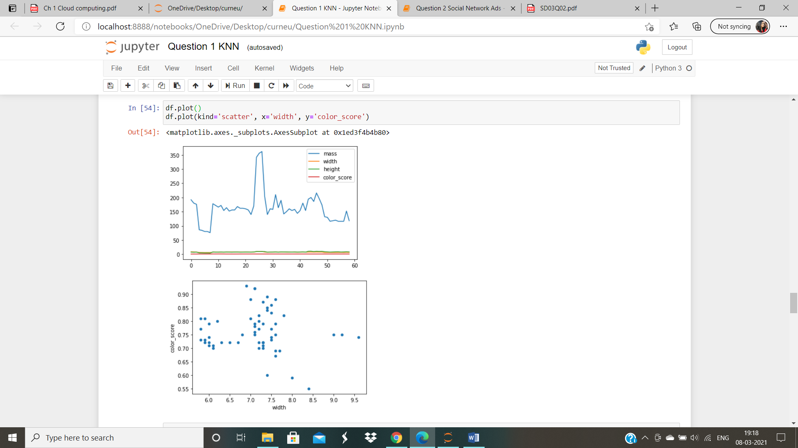

Cell 13: Scatter plot of color_score and mass

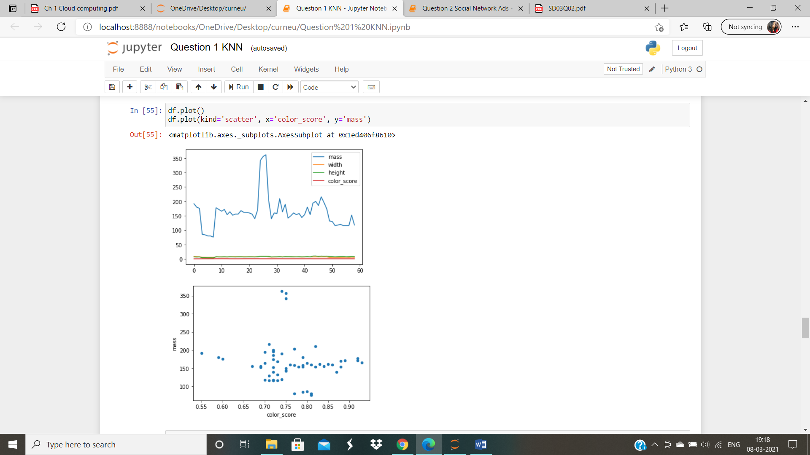

Cell 14: Scatter plot of color_score and width

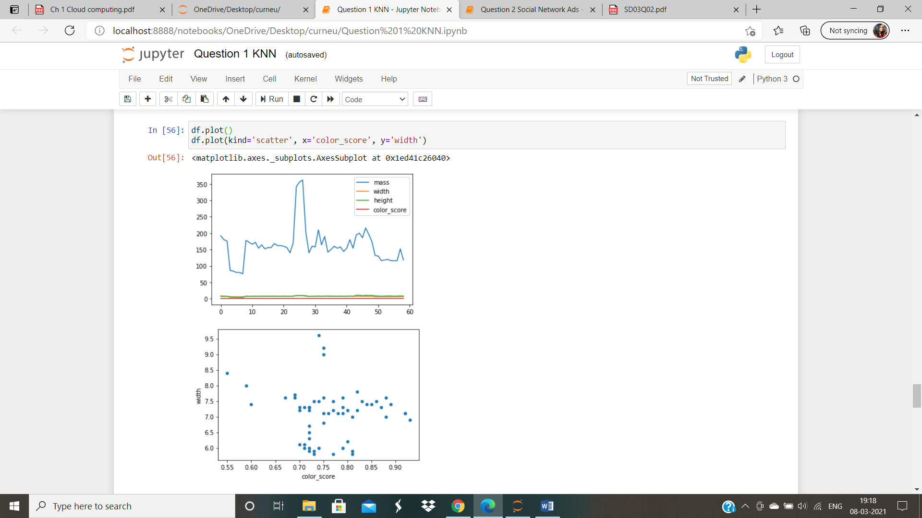

Cell 15: Scatter plot of color_score and height 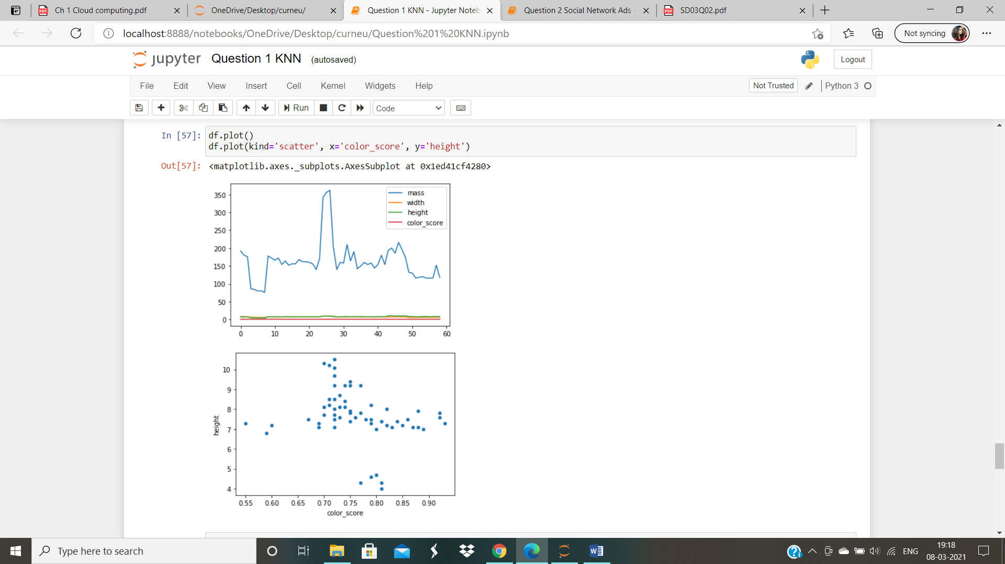

Cell 16: Splitting the dataset

Cell 17:Using KNN classifier

Cell 18: Generating the confusion matrix and classification report

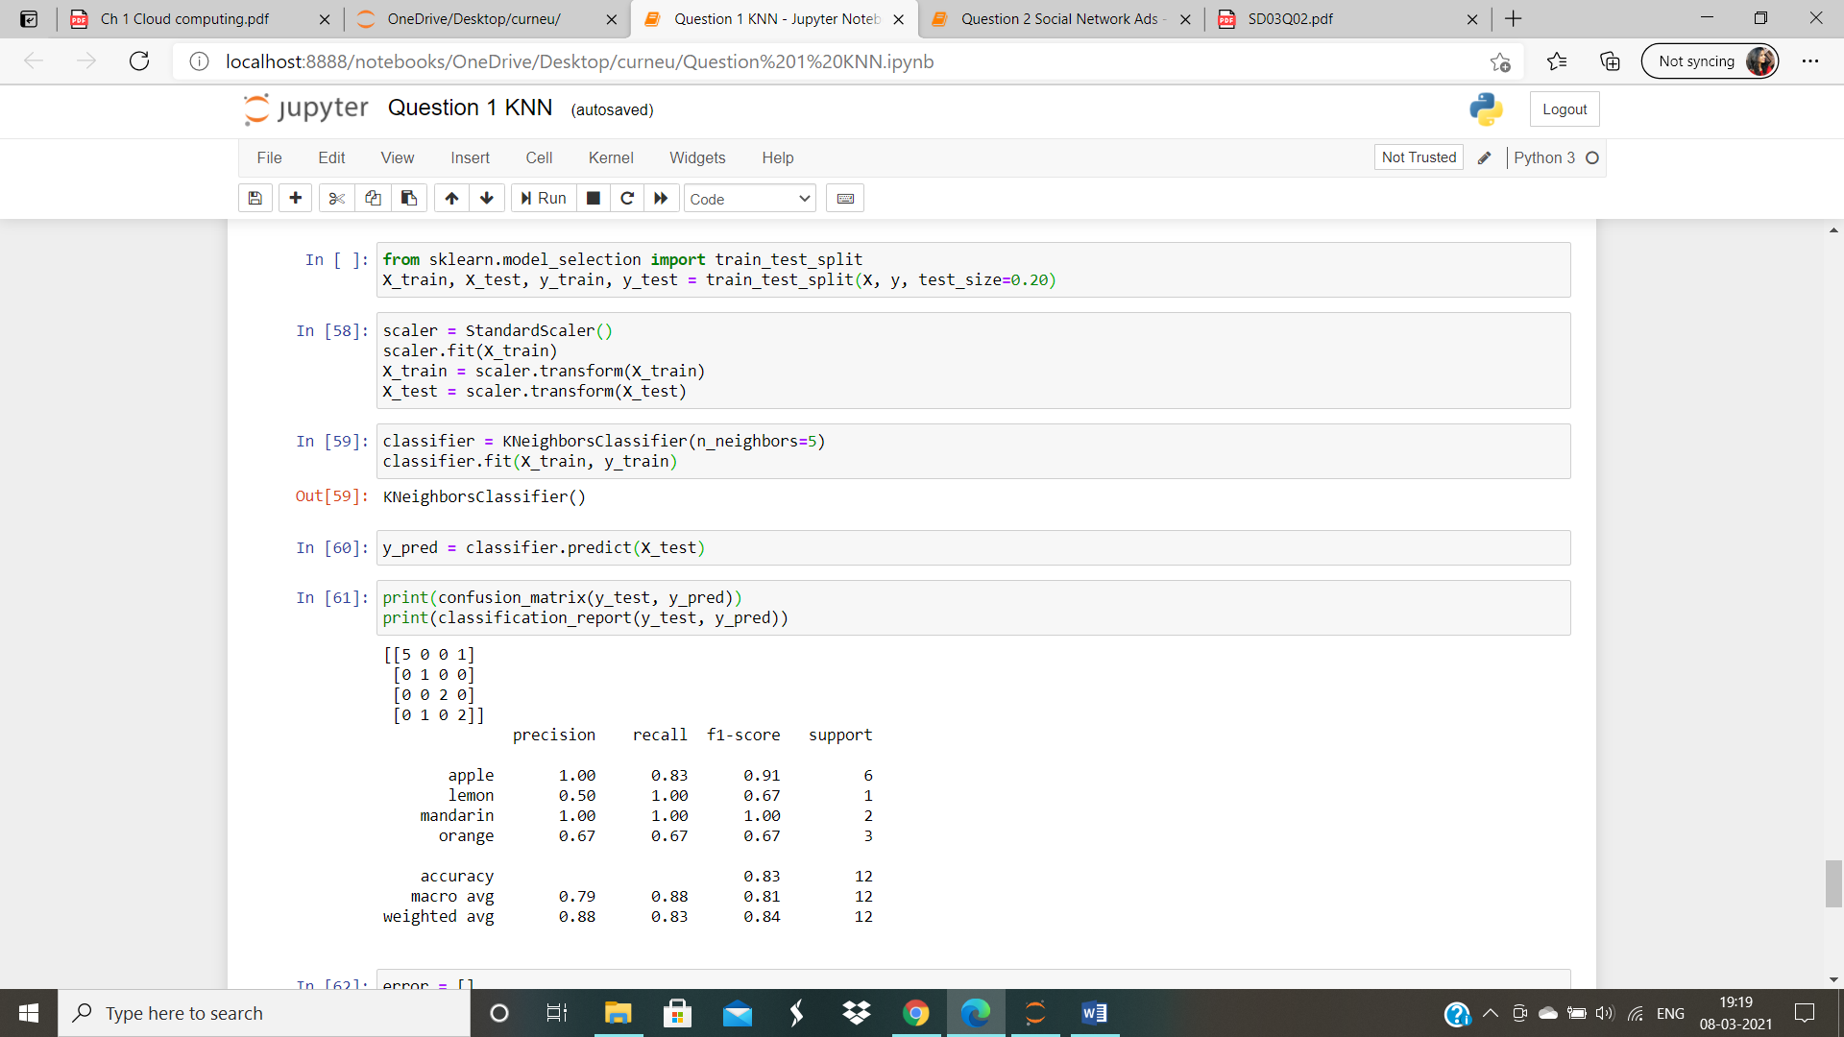

Cell 19: Calculating the error for K values

Cell 20: Plotting the Graph for the Mean Error and Error rate K value

